Yiddish id Tuva
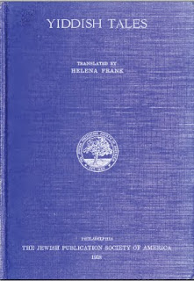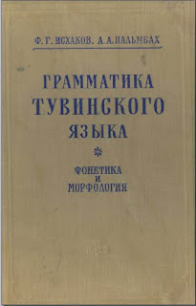
Luw gruks adailáblà éládèd dí Yiddish id Tuva lánslóaslàs!
:::
New books available related to Yiddish and Tuva languages!

Lùdè yt y lólán dí afwùrd lessódde éasòarksl fudd Yiddish lòésòrdadion.
:::
Note that we [pretend, seek] to [afford, perform] massive research on Yiddish preservation.

S'Tuva slàemler idda alsò slípt sha ésòarksl ilúdiadiddes.
:::
The Tuva grammar is also kept for research initiatives.
by Ayndryl on Friday, December 04, 2009
Labels Ladd cryptolect

